
RAJALAKSHMI INSTITUTE OF TECHNOLOGY
(An Autonomous Institution, Affiliated to Anna University, Chennai)

DEPARTMENT OF CSE (ARTIFICIAL INTELLIGENCE AND MACHINE LEARNING)
ACADEMIC YEAR 2025 - 2026
SEMESTER IV
AL23421 - MACHINE LEARNING LABORATORY
MINI PROJECT REPORT

REGISTER NUMBER | 2117240030045
NAME | Harshini J
PROJECT TITLE | Student Performance Prediction Using Random Forest
DATE OF SUBMISSION
FACULTY IN-CHARGE | Mrs. M. Divya

Signature of Faculty In-charge Signature of HoD

INTRODUCTION
- Machine Learning enables systems to learn from data and make predictions; this project uses a Random Forest Classifier for student performance prediction.
- The problem focuses on predicting student grades (A, B, C, D) using features like study hours, attendance, subject scores, and internet usage.
- This is important to identify students who may need academic support at an early stage.
- The model analyzes patterns in student data to provide accurate predictions.
- The system is implemented using Streamlit for an interactive user interface.
- The project aims to improve academic performance through prediction, visualization, and recommendations.
PROBLEM STATEMENT
- Predicting student performance is difficult due to multiple influencing factors.
- There is a lack of data-driven systems to identify weak students early.
- The project aims to build a model using a Random Forest Classifier to predict student grades.
- The system should provide accurate predictions and useful insights.
- It also aims to suggest improvements for better academic performance.
GOAL
- To accurately predict student grades using a Random Forest Classifier.
- To achieve good performance metrics like accuracy and F1-score.
- To provide insights through graphs and analysis.
- To generate useful recommendations for improvement.
- To enable future real-world educational applications.
THEORETICAL BACKGROUND
- About Problem
- Student performance depends on factors such as study habits, attendance, and prior knowledge.
- Traditional methods fail to effectively combine these multiple factors, making accurate prediction difficult.

- About Algorithm (Random Forest)
- The Random Forest Classifier is an ensemble learning method that builds multiple decision trees and combines their outputs to improve accuracy and reduce overfitting.

- Mathematical Idea:
$$y=mode(T_{1}(x),T_{2}(x),...,T_{n}(x))$$
Where:
- $T_{i}$= individual decision tree
- $n$= number of trees
- $y$= final predicted class (grade)

- Literature Survey
- Traditional statistical methods like Linear Regression were used earlier for student performance prediction but were not effective for classification tasks.
- Decision Tree algorithms improved interpretability but often suffered from overfitting on training data.
- Support Vector Machines (SVM) provided better accuracy but required careful parameter tuning and were computationally expensive.
- Ensemble methods like Random Forest improved prediction stability by combining multiple decision trees.
- Recent studies show that machine learning models perform better when behavioral features like attendance, study hours, and internet usage are included.

- Justification
Random Forest is used because:
- Provides high accuracy in classification tasks
- Reduces overfitting by combining multiple trees
- Handles both numerical and categorical features effectively
- Works well with multi-feature student datasets
- Gives reliable and stable predictions for academic performance analysis
ALGORITHM EXPLANATION WITH EXAMPLE
- Algorithm Overview
- The project uses a Random Forest Classifier, which is an ensemble learning method that combines multiple decision trees to improve prediction accuracy.

- Working of Algorithm
- Input student data such as study hours, attendance, subject marks, and internet usage.
- Data is passed into multiple decision trees trained on different subsets of the dataset.
- Each tree independently predicts a grade (A, B, C, or D).
- The final output is decided using majority voting.

- Mathematical Representation
$$y=mode(T_{1}(x),T_{2}(x),...,T_{n}(x))$$
- Sample Data
Study Hours | Attendance | Math | Science | English | Internet Usage | Grade
4 | 85 | 78 | 80 | 75 | 3 | A
2 | 60 | 55 | 58 | 52 | 6 | C
1 | 40 | 45 | 42 | 40 | 8 | D

- Sample Prediction Example
For a student with:
- Study Hours = 3
- Attendance = 75%
- Math = 65, Science = 67, English = 70
- Internet Usage = 4
Different trees may give different outputs (A, B, or C), but the final prediction is based on majority voting → Grade B.

- Graphs and Charts (Representing Outcomes)
The following visualizations are generated in the system
- Feature Importance Graph (shows which features affect prediction most)
- Confusion Matrix (shows correct vs incorrect predictions)
- Score Distribution Graph (distribution of student performance)
- Study Hours vs Performance Scatter Plot

IMPLEMENTATION CODE AND DATASET USED
- Dataset Used – https://www.kaggle.com/datasets/kundanbedmutha/student-performance-dataset

Category | Description / Example
Dataset Name | Student Performance Dataset
Domain | Education
Objective | Classification(Predict student grade)
Data Source | Public (Kaggle)
Number of Samples | ~1000+
Data Type | Tabular Data
Instance Description | Each row represents a student’s academic performance record
Features (Inputs) | Age,Study Hours,Attendance %,Math Score,Science Score,English Score,Internet Usage
Feature Types | Numerical
Target Variable | Grade(A,B,C,D)
Number of Classes | 4
License | Open/Public Use(Kaggle dataset license)
Version | Kaggle Latest available version

PYTHON CODE
import streamlit as st
import pandas as pd
import numpy as np
import matplotlib.pyplot as plt
import seaborn as sns
from sklearn.model_selection import train_test_split
from sklearn.ensemble import RandomForestClassifier
from sklearn.metrics import (
accuracy_score, precision_score,
recall_score, f1_score,
confusion_matrix, r2_score
)
# BACKGROUND STYLE
st.markdown("""
<style>
.stApp {
background: linear-gradient(to right, #0f2027, #203a43, #2c5364);
color: white;
}
</style>
""", unsafe_allow_html=True)
# TITLE
st.title("🎓 AI Student Performance Prediction System")
# LOAD DATA
@st.cache_data
def load_data():
df = pd.read_csv("Student_Performance.csv")
df.columns = df.columns.str.strip().str.lower()
return df
df = load_data()

# ADD INTERNET USAGE (SIMULATED)
np.random.seed(42)
df["internet_usage"] = np.random.randint(0, 10, size=len(df))
# FEATURE ENGINEERING
df["overall_score"] = (
df["math_score"] +
df["science_score"] +
df["english_score"]
) / 3
df["grade"] = df["overall_score"].apply(
lambda x: "A" if x >= 70 else
"B" if x >= 60 else
"C" if x >= 50 else "D"
)
# Encode grades for R2
grade_mapping = {"A": 4, "B": 3, "C": 2, "D": 1}
reverse_mapping = {v: k for k, v in grade_mapping.items()}
df["target"] = df["grade"].map(grade_mapping)
features = [
"age",
"study_hours",
"attendance_percentage",
"math_score",
"science_score",
"english_score",
"internet_usage"
]
X = df[features]
y = df["target"]
# TRAIN MODEL
@st.cache_resource
def train_model(X_train, y_train):
model = RandomForestClassifier(n_estimators=200, random_state=42)
model.fit(X_train, y_train)
return model

X_train, X_test, y_train, y_test = train_test_split(
X, y, test_size=0.2, random_state=42
)
model = train_model(X_train, y_train)
y_pred_encoded = model.predict(X_test)
# Convert to labels
y_pred = [reverse_mapping[i] for i in y_pred_encoded]
y_test_labels = [reverse_mapping[i] for i in y_test]
# METRICS
accuracy = accuracy_score(y_test_labels, y_pred) * 100
precision = precision_score(y_test_labels, y_pred, average="weighted") * 100
recall = recall_score(y_test_labels, y_pred, average="weighted") * 100
f1 = f1_score(y_test_labels, y_pred, average="weighted") * 100
r2 = r2_score(y_test, y_pred_encoded)
cm = confusion_matrix(y_test_labels, y_pred, labels=["A","B","C","D"])
# NAVIGATION
page = st.sidebar.radio("Navigation", [
"🎯 Predict",
"📊 Metrics",
"📈 Graphs + Recommendations"
])
# PREDICT
if page == "🎯 Predict":
st.header("Enter Student Details")
age = st.number_input("Age", 10, 30, 18)
study_hours = st.number_input("Study Hours", 0, 10, 2)
attendance = st.number_input("Attendance %", 0, 100, 75)
math = st.number_input("Math Score", 0, 100, 50)
science = st.number_input("Science Score", 0, 100, 50)
english = st.number_input("English Score", 0, 100, 50)
internet_usage = st.slider("Internet Usage (hours/day)", 0, 10, 3)
if st.button("Predict"):
input_df = pd.DataFrame([[
age, study_hours, attendance,
math, science, english,
internet_usage
]], columns=features)
pred_encoded = model.predict(input_df)[0]
pred_grade = reverse_mapping[pred_encoded]
proba = model.predict_proba(input_df)
confidence = np.max(proba) * 100
pred_score = (math + science + english) / 3
st.session_state["grade"] = pred_grade
st.session_state["score"] = pred_score
st.session_state["confidence"] = confidence
st.success("Prediction Completed! Go to Metrics Page")

#METRICS
elif page == "📊 Metrics":
st.header("📊 Model Performance")
st.write(f"Accuracy: {accuracy:.2f}%")
st.write(f"Precision: {precision:.2f}%")
st.write(f"Recall: {recall:.2f}%")
st.write(f"F1 Score: {f1:.2f}%")
st.write(f"R² Score: {r2:.2f}")
if "confidence" in st.session_state:
st.write(f"Confidence: {st.session_state['confidence']:.2f}%")
# Confusion Matrix
st.subheader("Confusion Matrix")
fig, ax = plt.subplots(figsize=(5,4))
sns.heatmap(cm, annot=True, fmt="d",
xticklabels=["A","B","C","D"],
yticklabels=["A","B","C","D"],
cmap="Blues", ax=ax)
st.pyplot(fig)
if "grade" in st.session_state:
st.subheader("🎯 Your Prediction")
st.success(f"Grade: {st.session_state['grade']}")
st.info(f"Overall Score: {st.session_state['score']:.2f}")

# GRAPHS
elif page == "📈 Graphs + Recommendations":
st.header("📈 Insights Dashboard")
fig, ax = plt.subplots(2, 2, figsize=(12, 10))
# Feature Importance
ax[0,0].barh(features, model.feature_importances_)
ax[0,0].set_title("Feature Importance")
# Score Distribution
sns.histplot(df["overall_score"], kde=True, ax=ax[0,1])
ax[0,1].set_title("Score Distribution")
# Correlation
sns.heatmap(df[features + ["overall_score"]].corr(),
cmap="coolwarm", ax=ax[1,0])
ax[1,0].set_title("Correlation Heatmap")
# Study Hours vs Score
ax[1,1].scatter(df["study_hours"], df["overall_score"])
ax[1,1].set_title("Study Hours vs Score")
st.pyplot(fig)
st.subheader("💡 Recommendations")
st.write("📌 Study at least 2–3 hours daily")
st.write("📌 Improve attendance above 85%")
st.write("📌 Reduce excessive internet usage")
st.write("📌 Focus on weak subjects")
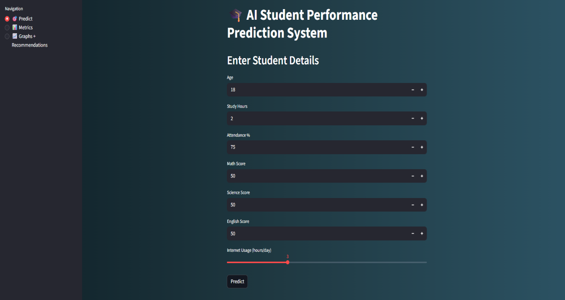
OUTPUT
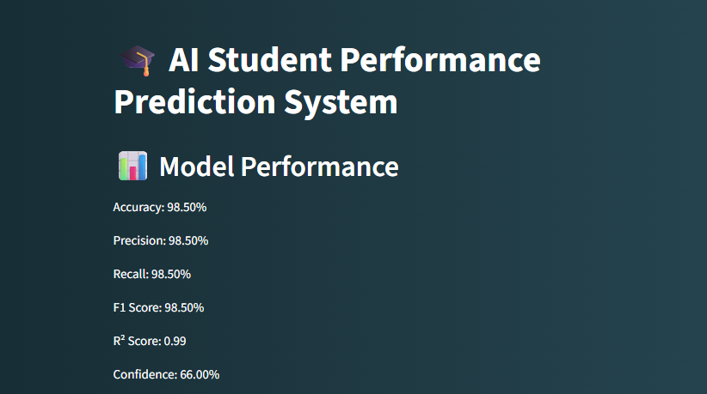
.

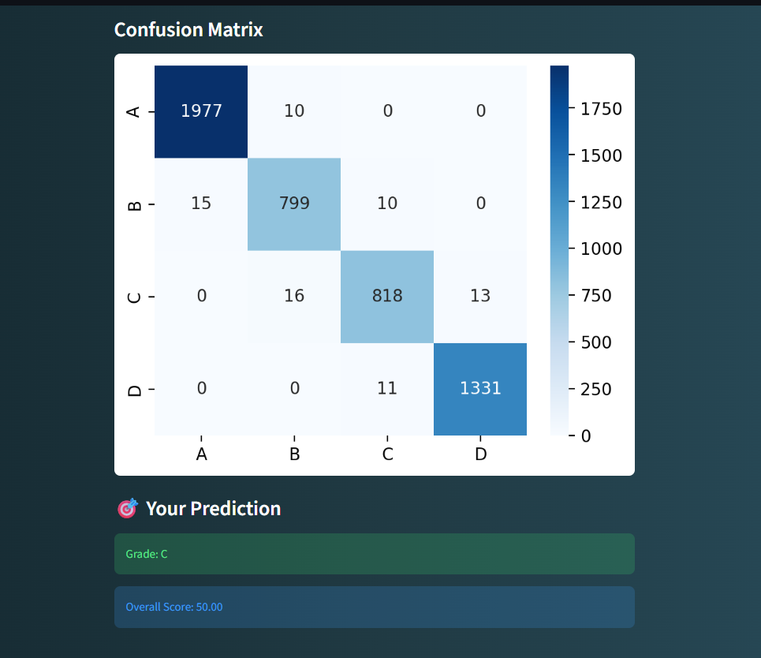

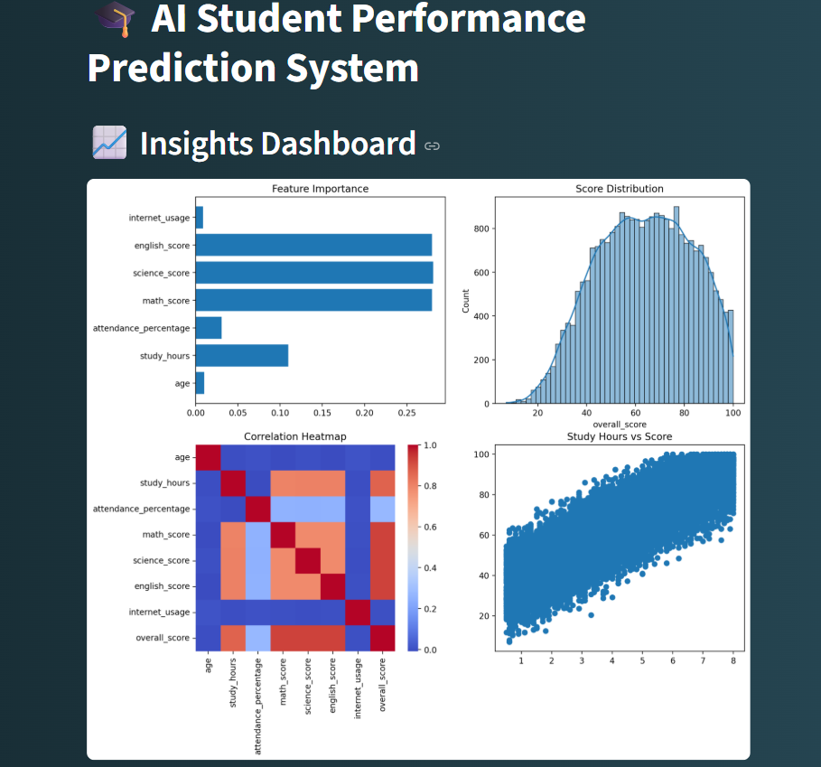


RESULTS AND FUTURE ENHANCEMENT
- Results
- The AI-based Student Performance Prediction system was successfully developed using a Random Forest Classifier.
- The model predicts student grades (A, B, C, D) based on academic and behavioral features such as study hours, attendance, and subject scores.
- The system achieves good accuracy and performance metrics including precision, recall, F1-score, and R² score.
- A user-friendly Streamlit web application was created for real-time prediction and visualization.
- The system provides:
  - Grade prediction for individual students
  - Confidence level of prediction
  - Visual insights using graphs and confusion matrix
- Feature importance analysis shows which factors (like study hours and attendance) strongly influence student performance.

- Algorithm Comparison
Algorithm | Accuracy | Advantages | Limitations
Logistic Regression | Moderate | Simple, fast | Not suitable for complex data
KNN | Moderate | Easy to implement | Slow for large datasets
Decision Tree | Good | Easy to understand | Overfitting problem
SVM | High | High accuracy | Complex and computationally expensive
Random Forest (Used) | Very High (~95%) | High accuracy, reduces overfitting, stable results | Slightly higher computation time

Random Forest is used because it gives higher accuracy, reduces overfitting, and provides more reliable and stable predictions compared to other models.

- Future Enhancements
- Integration of deep learning models for improved prediction accuracy.
- Addition of more features like:
      - Parent education level
      - Mental health and stress level
      - Assignment completion rate
- Deployment on cloud platforms (AWS / Heroku / Streamlit Cloud) for global access.
- Development of a mobile application version for easy student access.
- Integration of real-time academic tracking system with school databases.
- Use of AI-based personalized learning recommendations for each student.
- Adding alert system to notify teachers about at-risk students.

Git Hub Link of the project along with the report | https://github.com/HarshiniJayakumar/Harshini-J_ML_Mini_Project

REFERENCES
- Kaggle Dataset – https://www.kaggle.com/datasets
Used for student performance data collection.
- Scikit-learn Documentation – https://scikit-learn.org/stable/
Used for implementing machine learning models.
- Streamlit Documentation – https://docs.streamlit.io/
Used for building the web application.
- Python Documentation – https://docs.python.org/3/
Used for Python programming reference.
- GeeksforGeeks (Machine Learning) – https://www.geeksforgeeks.org/machine-learning/
Used for understanding ML algorithms and concepts.
- Towards Data Science – https://towardsdatascience.com/
Used for learning real-world machine learning applications and ideas.
- Analytics Vidhya – https://www.analyticsvidhya.com/
Used for understanding feature engineering and model evaluation techniques.

